**Managing Variables and Inclusion**

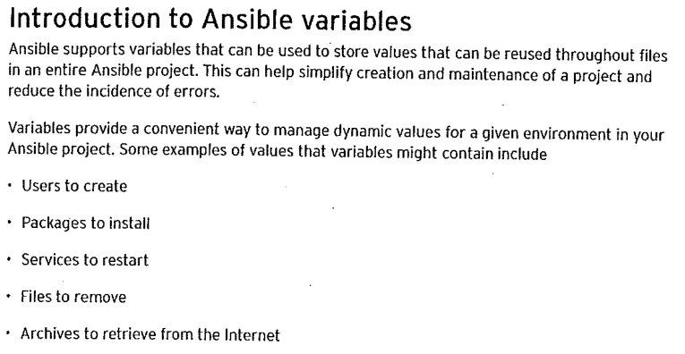

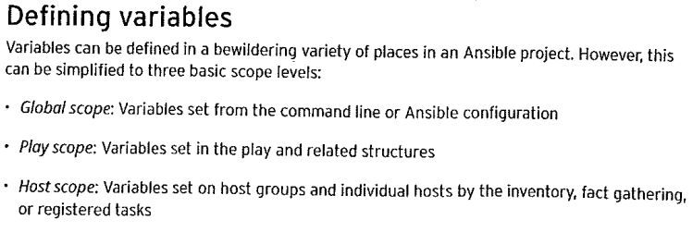

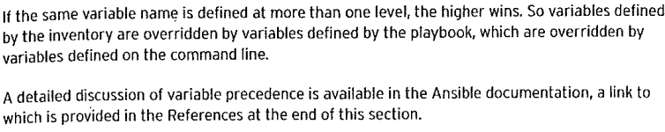

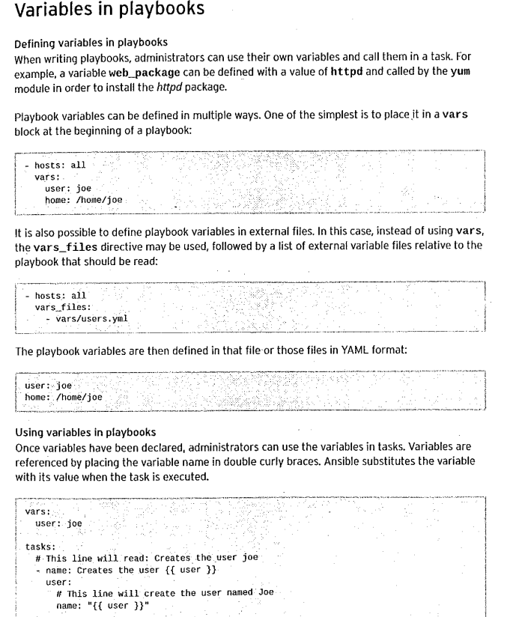

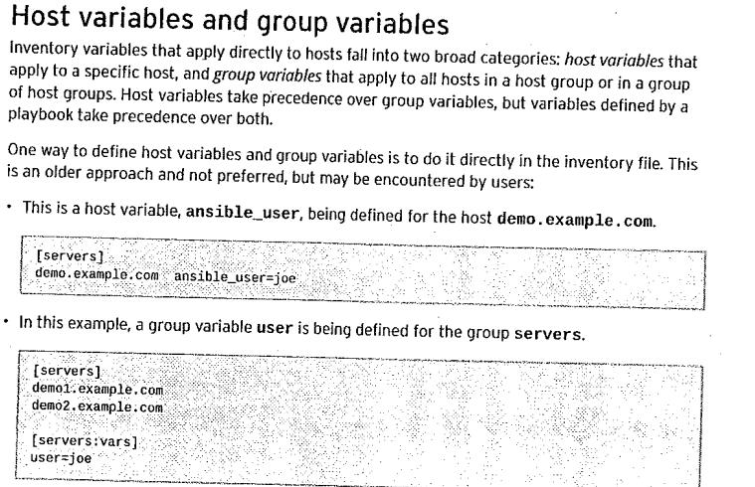

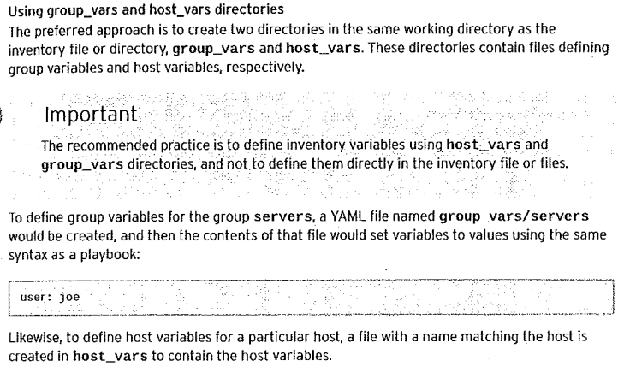

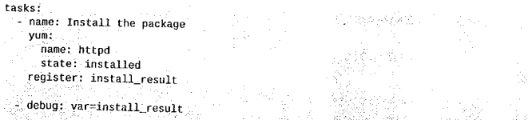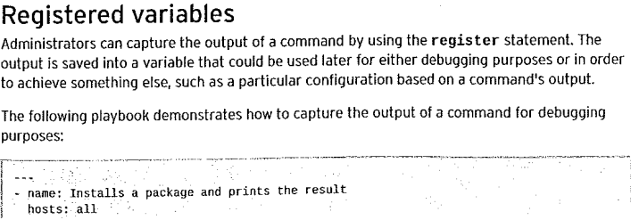

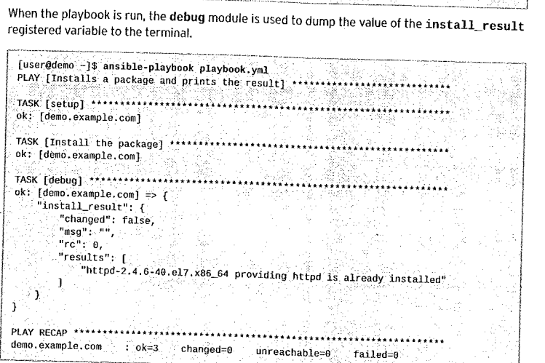

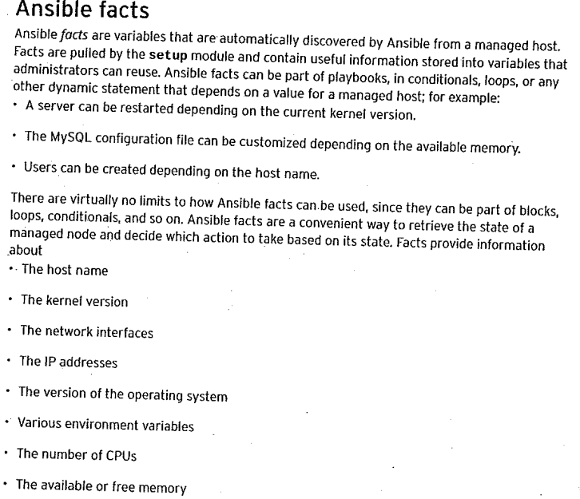

**# ansible node1 –m setup**

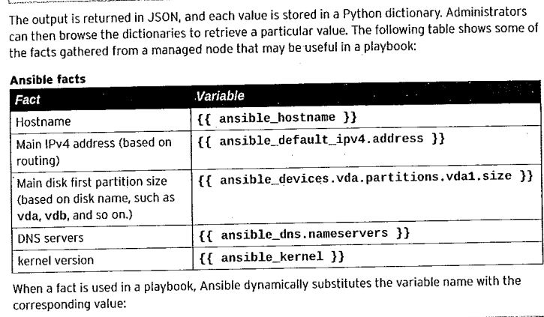

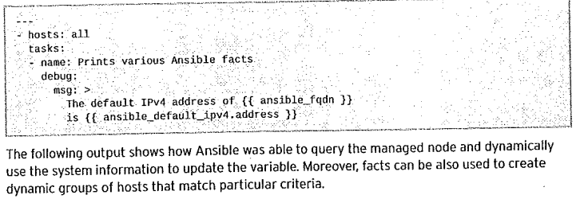

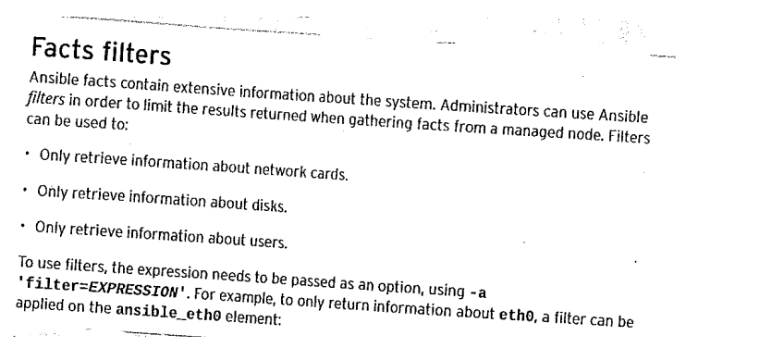

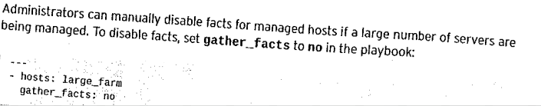

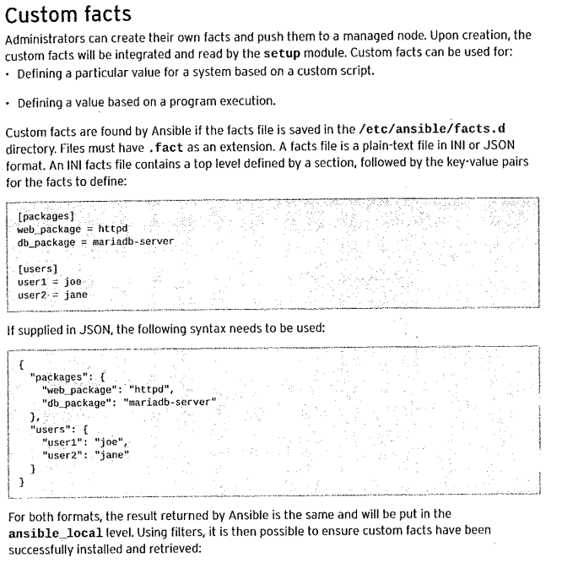

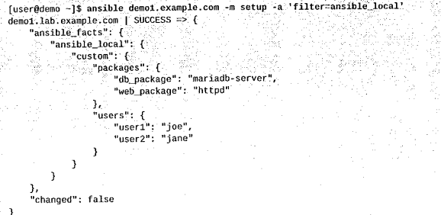

**[ansible@node1 project]$ cat /etc/ansible/facts.d/custom.fact**

**[packages]**

**web_package = httpd**

**db_package = mariadb-server**

**[users]**

**user1 = kalia**

**user2 = balia**

**[ansible@node1 project]$ cat /etc/ansible/facts.d/custom.fact**

**[packages]**

**web_package = httpd**

**db_package = mariadb-server**

**[users]**

**user1 = kalia**

**user2 = balia**

**[ansible@node1 project]$ cat custom_fact.yaml**

**---**

**- name: Testing Custom variable...**

**hosts: all**

**remote_user: ansible**

**become: true**

**vars:**

**remote_dir: /etc/ansible/facts.d**

**facts_file: custom.fact**

**tasks:**

**- name: Create the remote directory...**

**file:**

**path: "{{ remote_dir }}"**

**state: directory**

**recurse: yes**

**- name: copy custom.fact file to remote...**

**copy:**

**src: /etc/ansible/facts.d/custom.fact**

**dest: /etc/ansible/facts.d/**

**- name: Install package on remote hosts...**

**yum:**

**name:**

**- "{{ ansible_local.custom.packages.web_package }}"**

**state: latest**

**register: output**

**- debug: var=output**

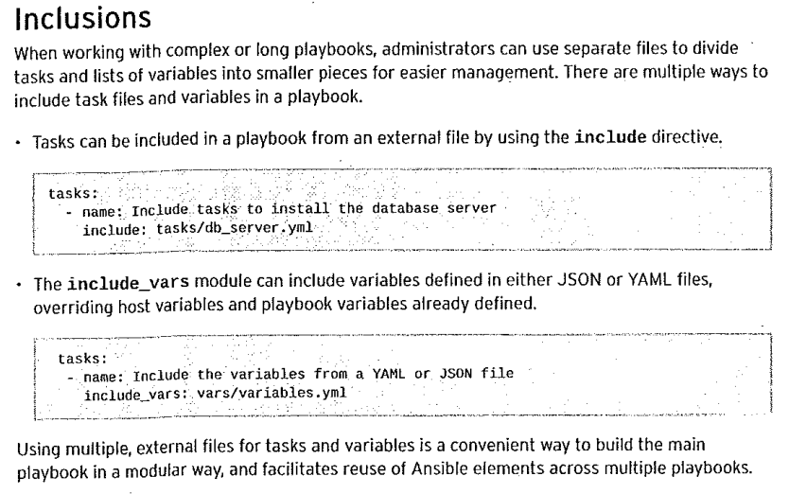

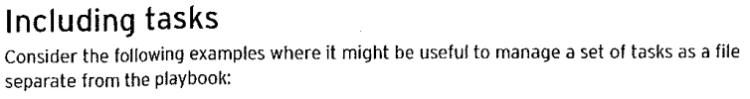



**[ansible@node1 project]$ cat enviroment.yaml**

**- name: Install the {{ package }} package....**

**yum:**

**name: "{{ package }}"**

**state: latest**

**- name: start the {{ service }} service...**

**service:**

**name: "{{ service }}"**

**state: "{{ state }}"**

**[ansible@node1 project]$ cat inclusion.yaml**

**- name: Test inclsuion file...**

**hosts: all**

**become: true**

**remote_user: ansible**

**tasks:**

**- name: imoprting inclusion file...**

**include: enviroment.yaml**

**vars:**

**package: mariadb-server**

**service: mariadb**

**state: started**

**register: Ga**

**- name: Debug output...**

**debug: var=Ga**

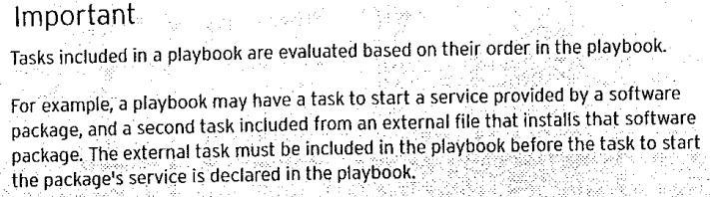

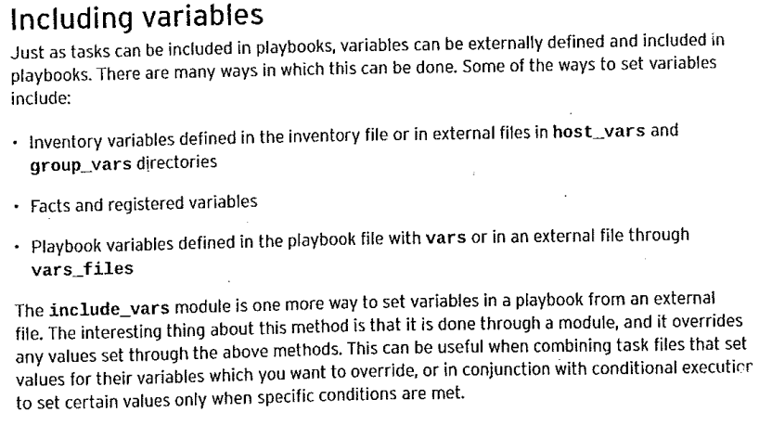

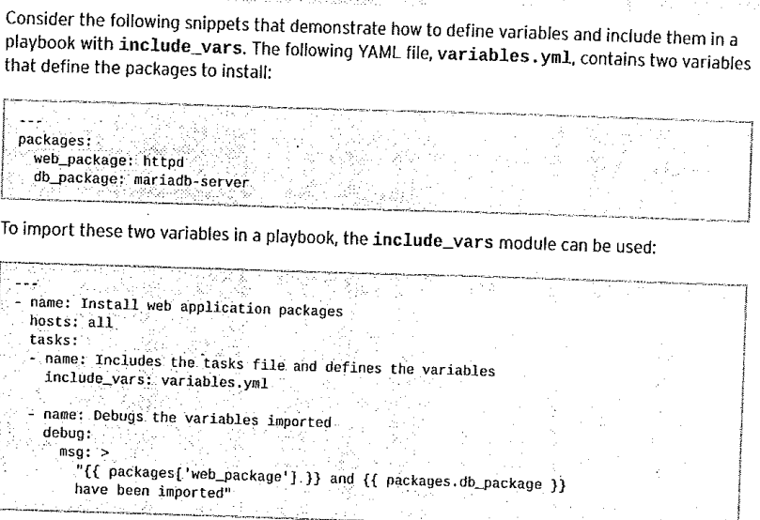

**[ansible@node1 project]$ cat paths.yml**

**---**

**paths:**

**fileserver: /home/ansible/test/{{ ansible_fqdn }}**

**dbpath: /home/ansible/test/db/{{ ansible_fqdn }}**

**[ansible@node1 project]$ cat fileserver.yml**

**---**

**- name: configure file server...**

**hosts: all**

**tasks:**

**- name: Import the variable....**

**include_vars: paths.yml**

**- name: create the file...**

**file:**

**path: "{{ paths.fileserver }}"**

**state: directory**

**mode: 0755**

**register: output**

**- name: show output...**

**debug:**

**var: output**

